DUY TAN UNIVERSITY
INTERNATIONAL SCHOOL




GROUP ASSIGNMENT
USE CYPRESS TOOL TO TESTING PROJECT “36FULLZ”
SOFTWARE TESTING

SUBMIT BY
Đặng Đại Việt
ID: 29211155820
CMU-SE 303 CIS

Da Nang, November 22, 2025

CONTENTS
I. Demo picture 2
1. Demo Tool Click Up 2
2. Demo Testcase 3

I. Demo picture

1. Demo Tool Click Up
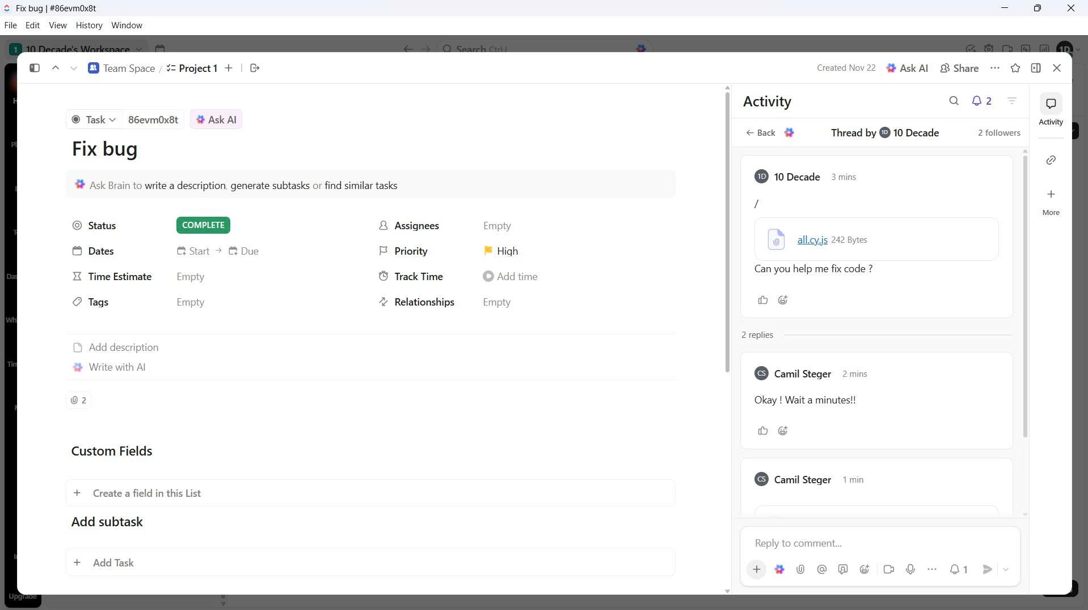


2. Demo Testcase
• Automated Test Cases:
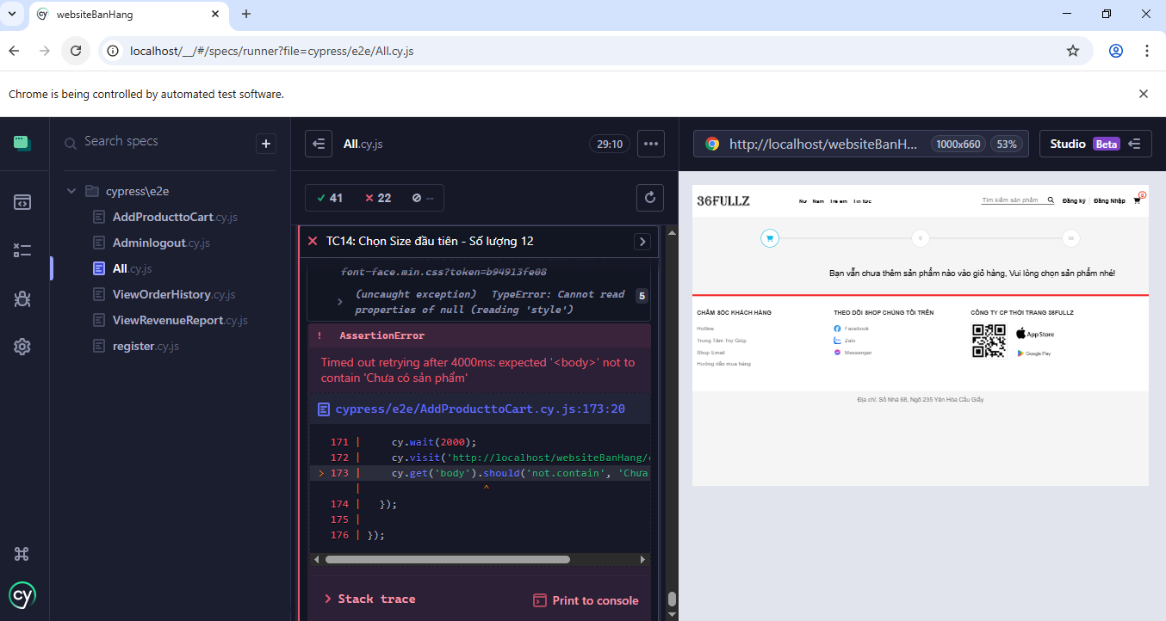
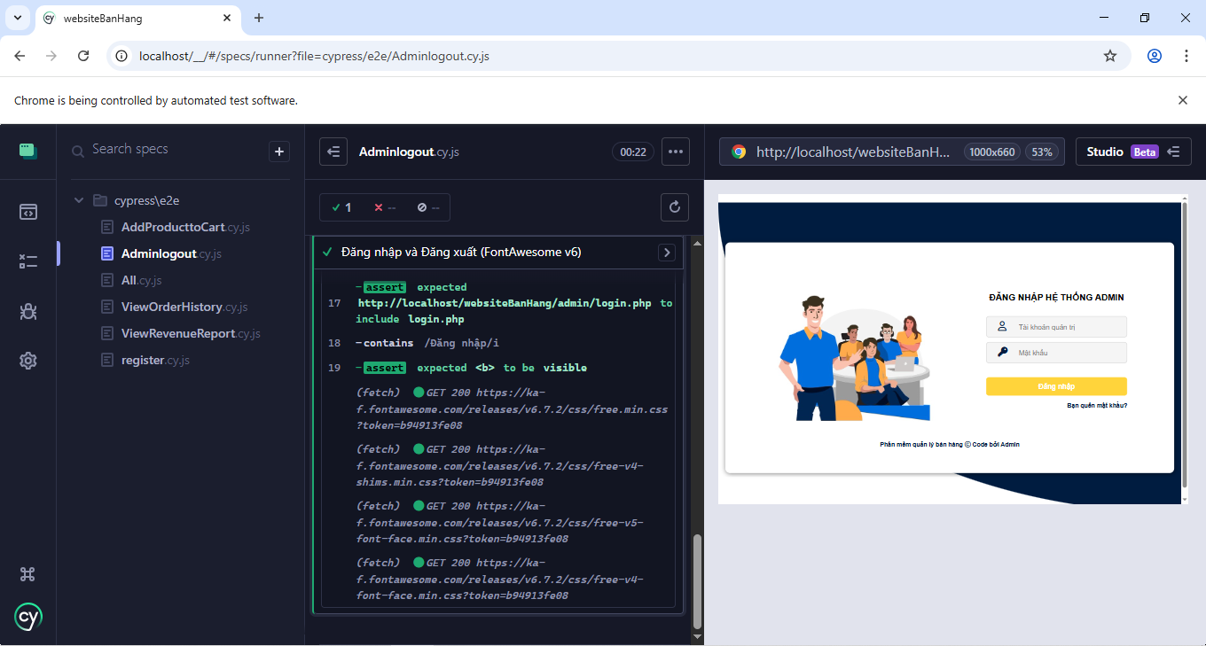
• Manual Test Cases – Manage Order:
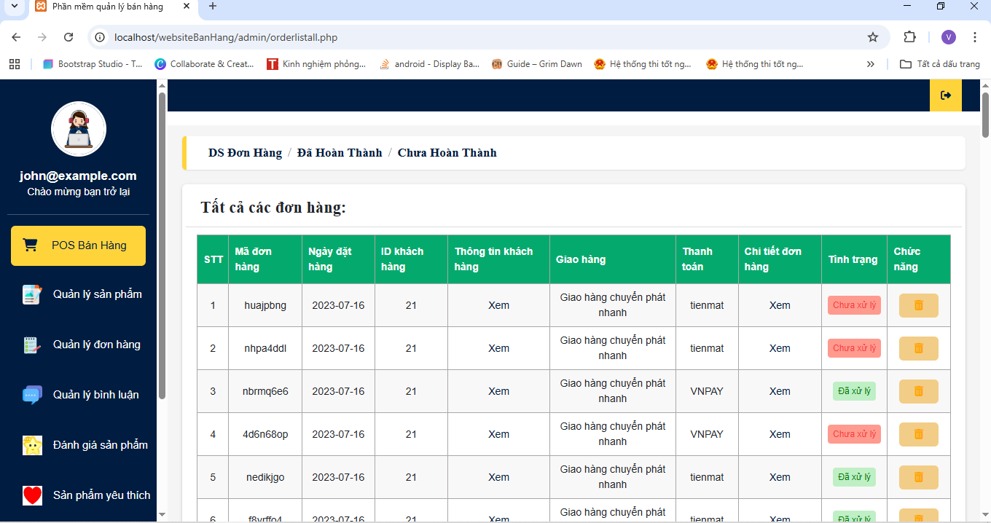
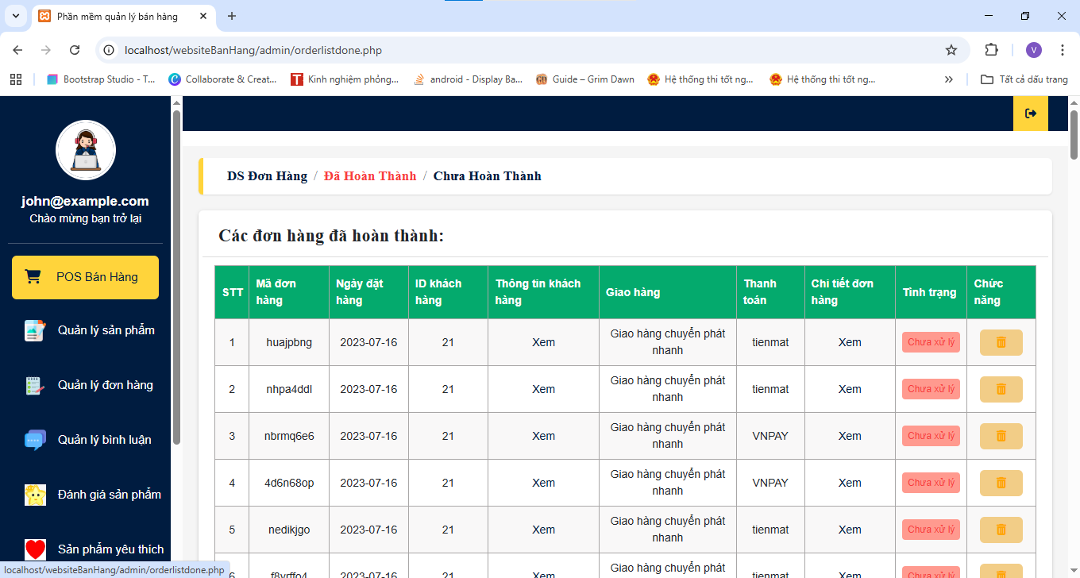
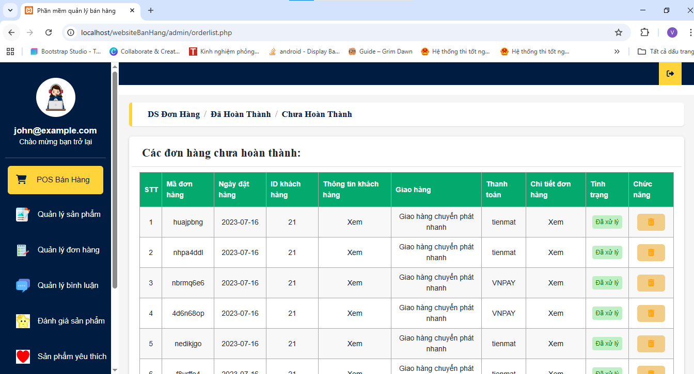
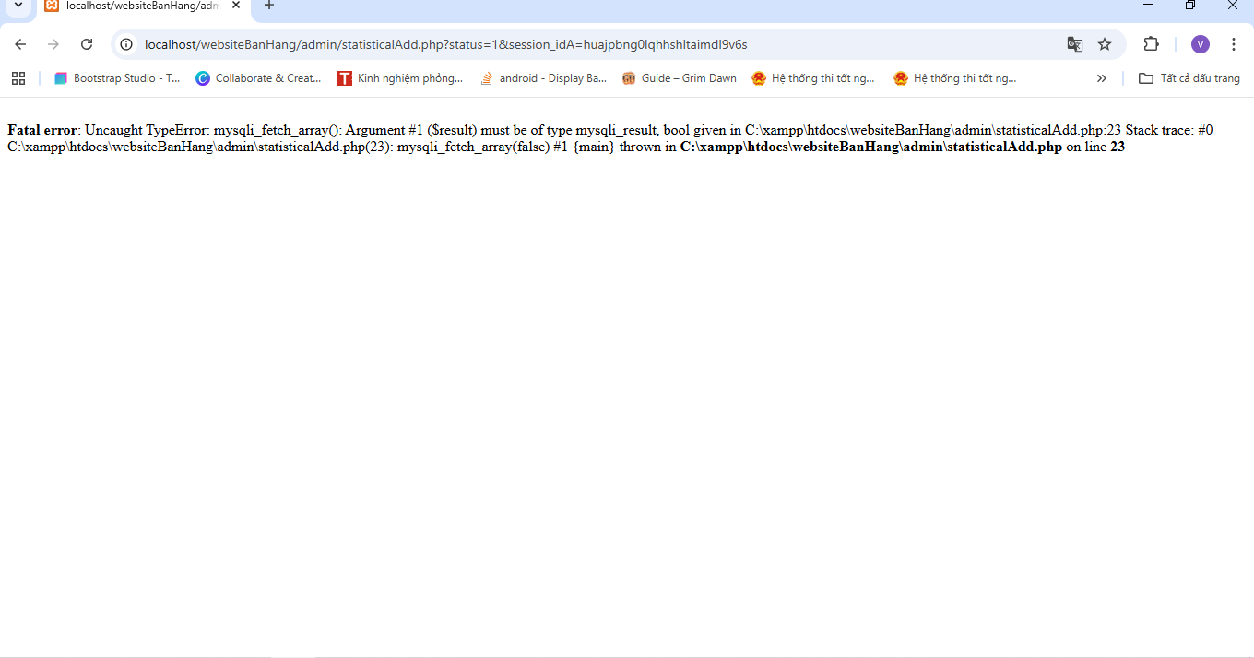

-END-

